Lab 6

Exercise 1 (While & Switch statement)
Write a program that calculates the volumes of different solids;
Cube: v = length * length * length
Cylinder: v = p * r² * height
Sphere: v = (4 / 3) * p * r³
where length is the length of each side of the cube, height is the height of the cylinder, r is the radius of the cylinder base or of the sphere, and p is the mathematical constant . Use the constant Math.PI as the value for p.

Display a menu to the user so that they can select the type of solid they wish.

Sample output:

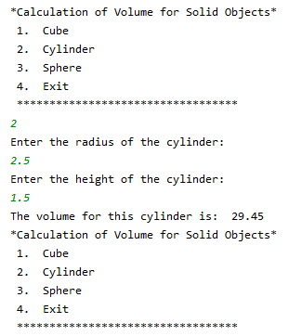

When the user selects an option the program should ask the user to enter the appropriate information as outlined in the formulae above, calculate the volume, display the volume and redisplay the menu until the user chooses the exit option.

Exercise 2 (Nested While loop)
A college department has 3 research assistants. The department requires a program that tracks hours worked each week by the research assistants. The number of hours per day of research work performed by each research assistant is to be entered. Each research assistant works 5 days and from 0 to 9 hours per day. Assume that the hours entered are correct and the hours worked are within the permitted range.

You are required to develop a program which calculates and displays the average number of hours worked for each research assistant.

The program should also calculate and report the number of research assistants whose average number of hours per day is above 6. This result should be printed at the end of the program.

Exercise 3 (do while)
A car ferry company operates between Dublin and Hollyhead. They have hired you to write a Java program to process cars and passengers as they board their ferries. The following requirements must be incorporated:

- At least one car boards the ferry each day.
- As each car boards, it is stopped, and its registration is entered
- The system then needs to store the number of people in the car, this includes the driver
- If there is only 1 person in the car (i.e. the driver) then the charge is 100
- If there is more than 1 person, check each person in the car, the charge is 100 euro plus
  - 10 euro for each passenger under 18
  - 20 euro for each passenger 18 or over
- Once all passengers’ ages have been checked, the charge for the car is printed
- At the end when all cars are aboard, the total revenue and total number of people carried are printed followed by the number of cars travelling with only the driver

In Java use nextBoolean() to read true or false from the keyboard

See sample output on next page.

Sample Output – green text indicates user input

